###### Experiment Number: 01 OS

**Name : Jay Pawar Roll No : 22**

**Div : TY-CS-B Batch : B1**

###### TITLE: Study Of Unix Commands

**OBJECTIVES:**

1. To understand how to use Unix commands.
2. To understand How and Why they are used in Shell Programming

**Problems to be solved in the lab:**

1. Change your password to a password you would like to use for the remainder of the semester.

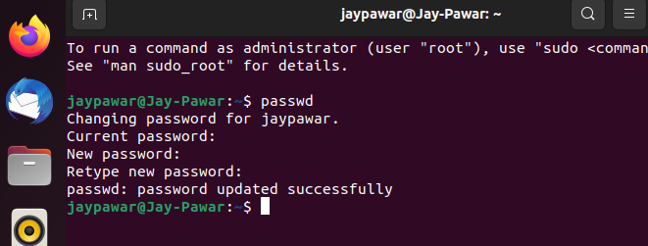

1. Display the system’s date.

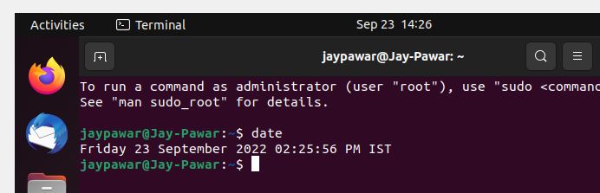

1. Count the number of lines in the /etc/passwd file.

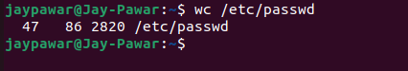

1. Find out who else is on the system.

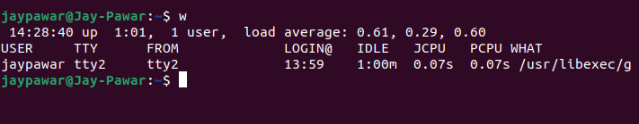

1. Direct the output of the man pages for the date command to a file named *mydate*.

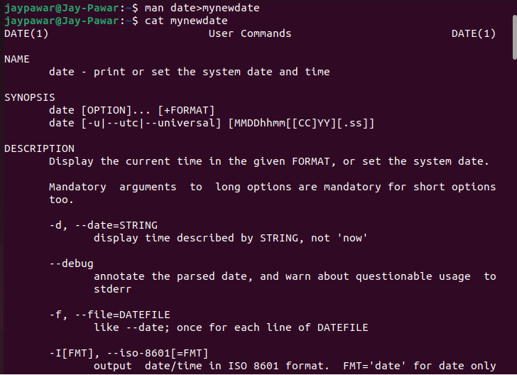

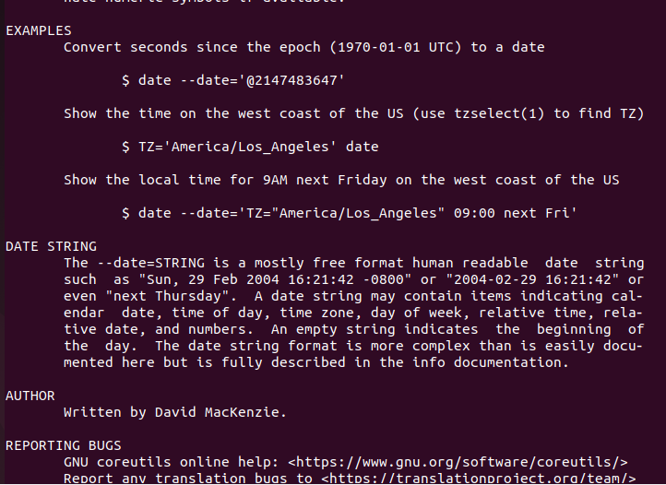

1. Create a subdirectory called *mydir*.

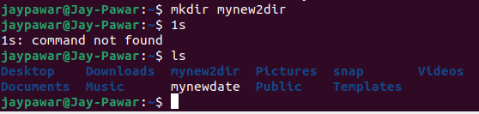

1. Move the file *mydate* into the new subdirectory.

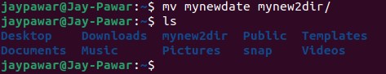

1. Go to the subdirectory *mydir* and copy the file *mydate* to a new file called *ourdate*

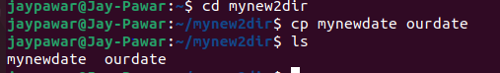

1. List the contents of *mydir*.



1. Do a long listing on the file *ourdate* and note the permissions.



1. Display the name of the current directory starting from the root.



1. Move the files in the directory *mydir* back to the HOME directory.

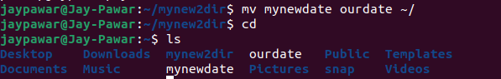

1. List all the files in your HOME directory.



1. Display the first 5 lines of *mydate*. 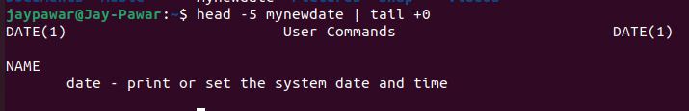
2. Display the last 8 lines of *mydate*.

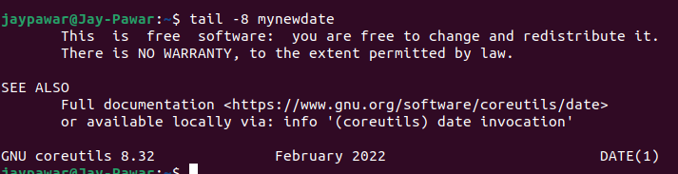

1. Remove the directory *mydir*.

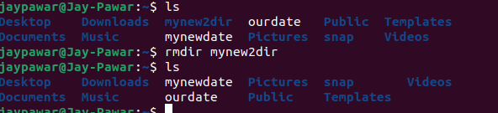

1. Redirect the output of the long listing of files to a file named *list*.

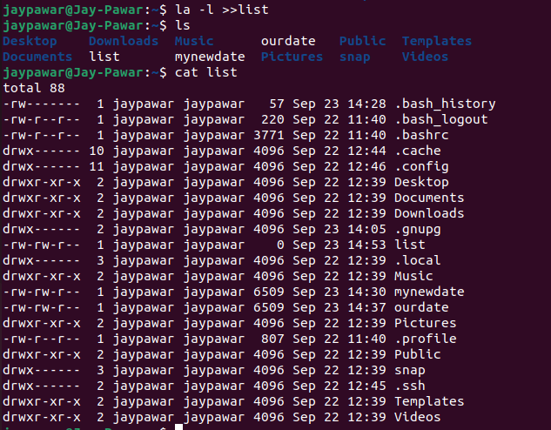

1. Select any 5 capitals of states in India and enter them in a file named *capitals1*. Choose 5 more capitals and enter them in a file named *capitals2*. Choose 5 more capitals and enter them in a file named *capitals3*. Concatenate all 3 files and redirect the output to a file named *capitals*.

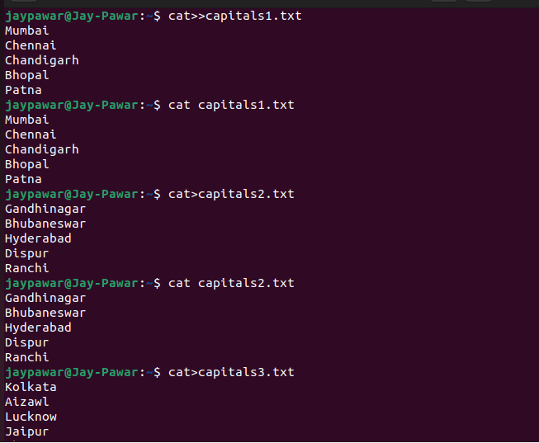

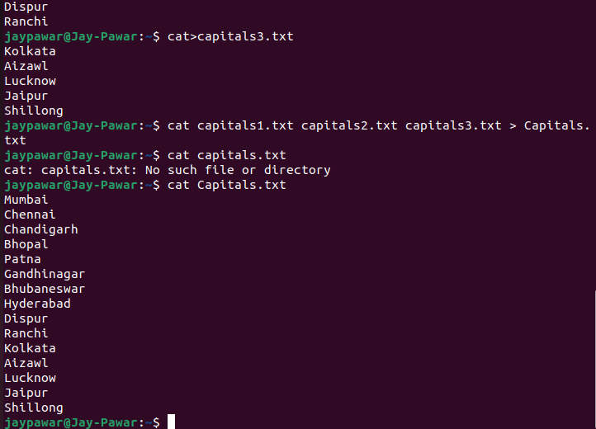

1. Concatenate the file *capitals2* at the end of file *capitals*.

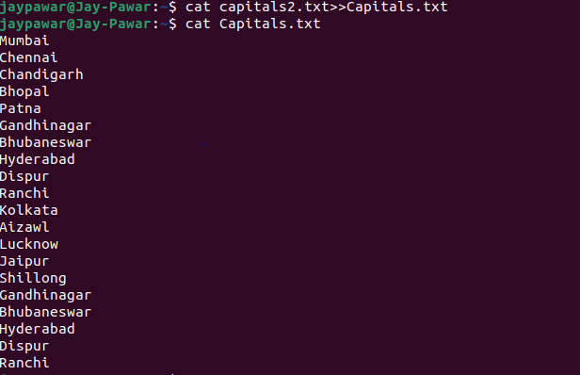

1. Redirect the file *capitals* as an input to the command “wc –l”.



1. Give read and write permissions to all users for the file *capitals*.

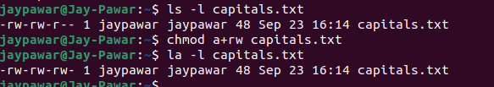

1. Give read permissions only to the owner of the file *capitals*. Open the file, make some changes and try to save it. What happens ?

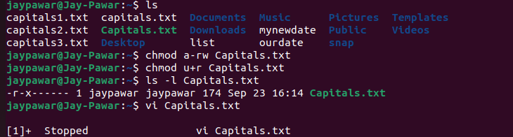

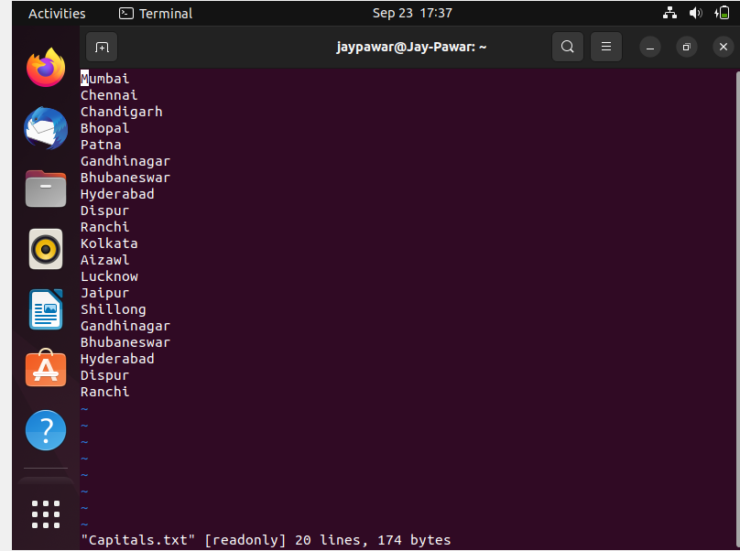

1. Create an alias to concatenate the 3 files *capitals1*, *capitals2*, *capitals3* and redirect the output to a file named *capitals*. Activate the alias and make it run.

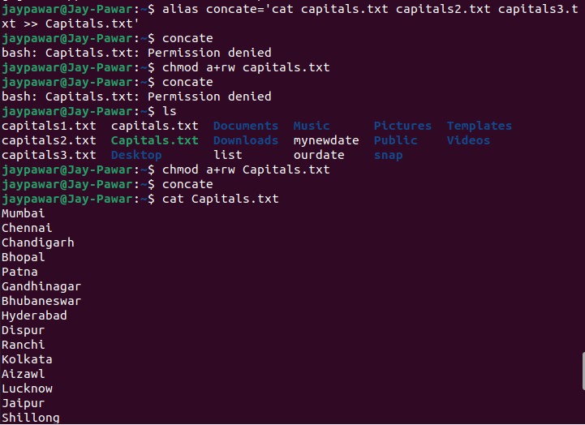

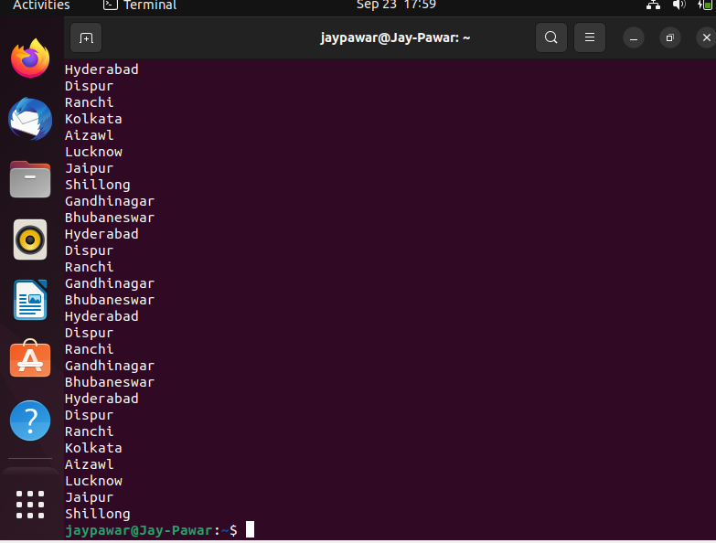

1. What are the environment variables PATH, HOME and TERM set to on your terminal?

PATH=

/usr/local/sbin:/usr/local/bin:/usr/sbin:/usr/bin:/sbin:/bin:/usr/games:/usr/local/games:/usr/lib/wsl/lib:/mnt/c/Program Files (x86)/Common Files/Oracle/Java/javapath:/mnt/c/Users/Dell_owner/Desktop/Softwares/bin:/mnt/c/WINDOWS/system32:/mnt/c/WINDOWS:/mnt/c/WINDOWS/System32/Wbem:/mnt/c/WINDOWS/System32/WindowsPowerShell/v1.0/:/mnt/c/WINDOWS/System32/OpenSSH/:/mnt/c/Program Files (x86)/mingw-w64/i686-8.1.0-posix-dwarf-rt_v6-rev0/mingw32/bin:/mnt/c/Program Files/Git/cmd:/mnt/c/Program Files (x86)/GnuWin32/bin:/mnt/c/Users/Dell_owner/AppData/Local/Programs/Python/Python36/Scripts/:/mnt/c/Users/Dell_owner/AppData/Local/Programs/Python/Python36/:/mnt/c/Users/Dell_owner/AppData/Local/Programs/Python/Python39/Scripts/:/mnt/c/Users/Dell_owner/AppData/Local/Programs/Python/Python39/:/mnt/c/Users/Dell_owner/AppData/Local/Microsoft/WindowsApps:/mnt/c/Users/Dell_owner/AppData/Local/Programs/Microsoft VS Code/bin:/mnt/c/Program Files/Java/jdk1.8.0_321/bin:/mnt/c/src/flutter/flutter/bin:/snap/bin

HOME=

/home/jaypawar

TERM=

xterm-256color

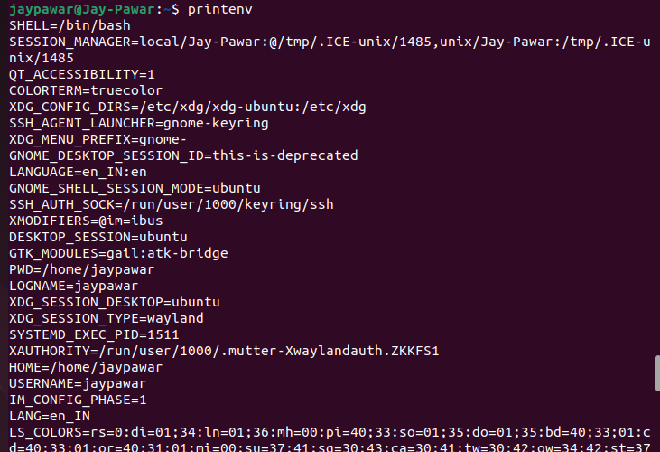

1. Find out the number of times the string “the” appears in the file *mydate*.



1. Find out the line numbers on which the string “date” exists in *mydate*

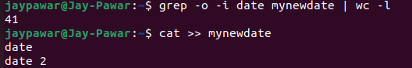



1. Print all lines of *mydate* except those that have the letter “i” in them.

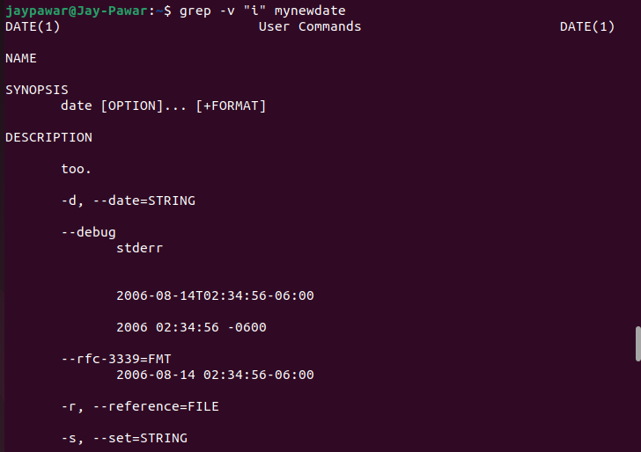

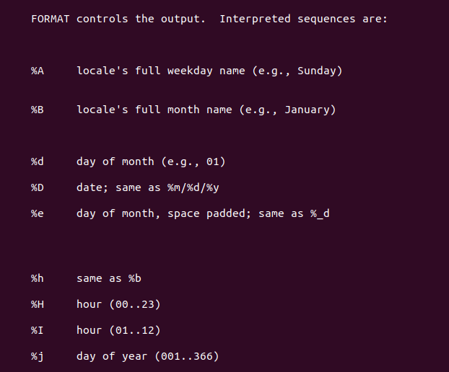

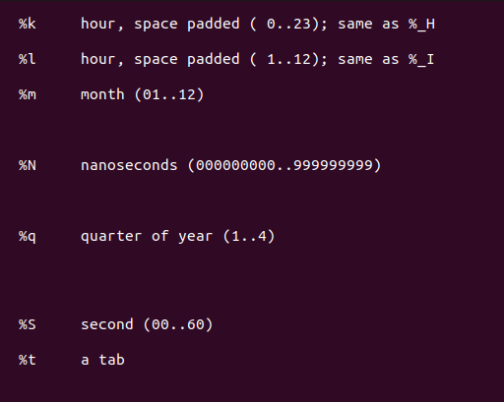

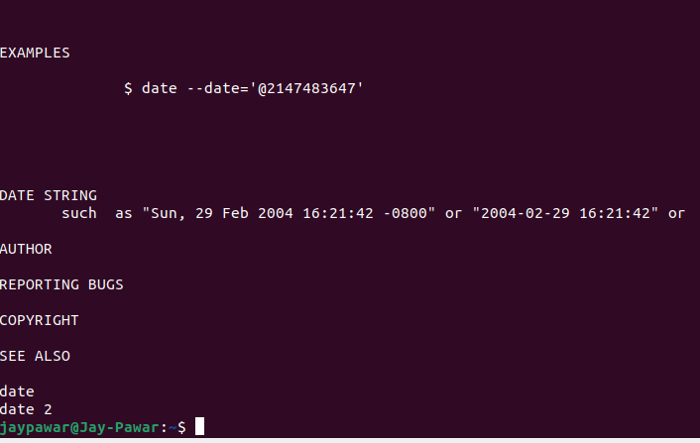

1. Create the file *monotonic* as follows:

^a?b?b?c?…………..x?y?z$

Run the egrep command for *monotonic* against /usr/dict/words and search for all 4 letter words.



1. List 5 states in north east India in a file *mystates*. List their corresponding capitals in a file *mycapitals*. Use the *paste* command to join the 2 files.

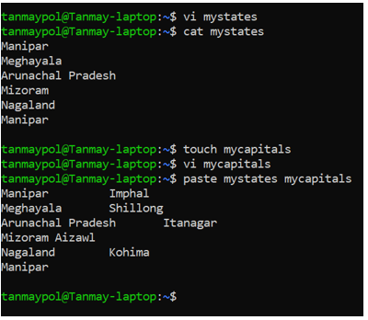

1. Use the *cut* command to print the 1st and 3rd columns of the /etc/passwd file for all students in this class.

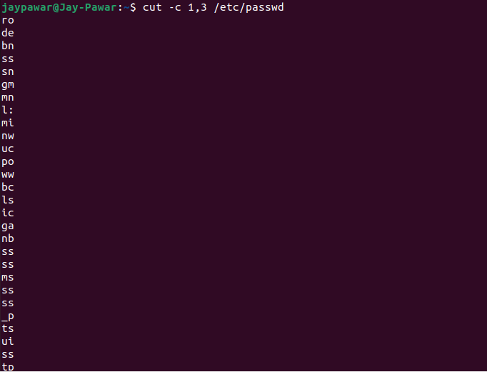

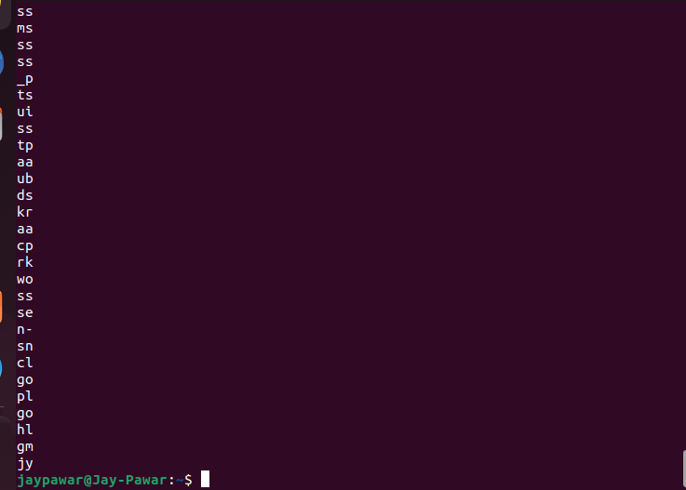

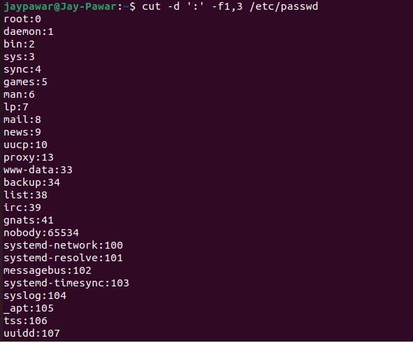

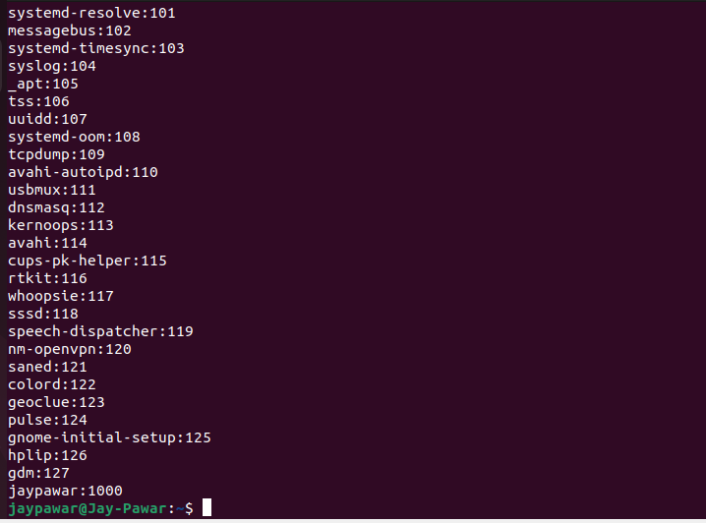

1. Count the number of people logged in and also trap the users in a file using the *tee* command.

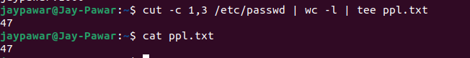

**APPLICATIONS**

1. To enable the user to communicate with the kernel through the command interpreter.
2. Useful in Shell Programming

FAQs

* 1. What is a pipe?
  2. What is a filter?
  3. What is the purpose of the grep command?
  4. How does input output redirection take place?
  5. What is an alias?